**DEVOP’S                                               .**



**DEV-** DEVELOPMENT

**OPS-** OPERATIONS

**SEC-** SECURITY

**SOFTWARE LIFE CYCLE:**

   PLAN

   CODE

   BUILD

   TEST

   RELEASE

   DEPLOY

  OPERATE                 OPS TEAM

Putty gen– used to convert the .pem to .ppk

Putty – used to authenticate keypair to remote ec2 instances.

**TOOLS:**

BUG TRACKING/ TICKETING TOOLS: track the application

JIRA--- JIRA STORY

REMEDY

SERVICE NOW

BUG SILLA

FOSSIL

<TRACK THE COMPLETE APPLICATION  like what is going on that application how much time spent on one particular activity.

VERSION CONTROL / SOURCE CODE MANAGEMENT TOOLS:

GIT , GIT HUB, GIT LAB

CLEAR CASE

PERFORCE

SVN(SUB VERSION)

BIT BUCKET

< TO MAINTAIN / STORE THE SOURCE CODE OF APPLICATION.

CODE QUALITY/ CODE REVIEW:

SONAR QUBE

VEVA CODE

HPE FORTIFY

DEEP SCAN

<TO IDENTIFY THE QUALITY OF THE CODE

THERE ARE USING DEVSECOP’S

BUILT TOOLS: compile

JAVA: ANT, MAVEN** , GRADLE

    AFTER COMPILATION THE EXTENSION OF FILE WILL BE LIKE ({ .JAVA, .EAR, .WAR } ARTIFACTS)

.NET: NANT, MIBUILD

NODEJS: NPM

C, C#: MAKE

PYTHON: PY BUILDERS

<COVERT THE JAVA, .NET… INTO MACHINE  UNDERSTANDING LANGUAGE

APPLICATION/ WEB BUILDERS:

JBOSS

APACHE TOMCAT

WEB SHERE

WEB LOGIC

WILD FLY

WILD LOGIC

NGIX

< TO EXPOSE APPLICATIONS IN TO INTERNET

AUTOMATION TESTING TOOLS:

SELENIUM

CUCUMBER

APPIUM

TEST COMPLETE

RANOREX

ARTIFACTORY REPOSITORY TOOLS:

SONAR TYPE NEXUS

JFROG

NPM

DOCKER HUB*

GCR- GOOGLE CONTAINER REGISTRY

ECR- ELASTIC CONTAINER REGISTRY

< WE ARE USING THIS TOOLS TO STORE THE COMPILED (ARTIFACTS) PROGRAMS

CONFIGURATION MANAGEMENT TOOLS:

ANSIBLE*

CHEF

JUJU

RUDDER

SALT STACK

PVPPET

<IT IS ALTERNATE FOR SCRIPTING LANGUAGES,, ALSO USED IN AUTOMATION TESTING

**CI/CD TOOLS:**

JENKINS*

BAMBOO

TEXTON

TEAMCITY

GOLD

GIT LAB CI

**OPERATING SYSTEMS:**

*LINUX,UNIX- FLAVOR ----🡪 AMAZON LINUX, RED HAT( COMPLETE COMMAND

.                                                                                                            BASED)

WINDOWS

IOS

**CONTAINERIZATION TOOLS:(MICRO SERVICES)**

DOCKER*

RKT

OPEN SHIFT

(used to convert monolithic tools into micro services)

**CONTAINERIZATION ORCHESTRATION TOOLS:**

DOCKER SWARM

KUBERNETES*

OPEN SHIFT

APACHE MEROS

(To maintain the scalability of the micro services)

**CLOUD PROVIDERS:**

AWS- AMAZON WEB SERVICES

GCP -GOOGLE CLOUD PROVIDERS

MICROSOFT-AZURE

DELL BHOOMI

IBM CLOUD

ORACLE CLOUD

VERIZON CLOUD

SALES FORCE

<PUBLIC –ANY BODY CAN USE

<PRIVATE—WITH IN THE ORGANIZATION

<HYBRID—BOTH PUBLIC AND PRIVATE CAN USE

**SCRIPTING LANGUAGES:**

SHELL SCRIPT

PYTHON

RUBY

PERL

POWER SHELL ( WINDOWS)

*YAML

< SCRIPTING LANGUAGES USED IN AUTOMATION

**IAAC (INFRASTRUCTURE ASO CODE):**

*TERRAFORM

AWS CLOUD FORMATION

GOOGLE CLOUD DEPLOYMENT MANAGER

MICROSOFT AZURE AUTOMATION

ANSIBLE

CHEF

PUPPET

SALT STACK

<TO LAUNCH SERVICES FOR APPLICATION DEPLOYMENT

**LOG MONITORING:**

SPLUNK

KIBANA

ELK

LOG FUSION

NEWRELIC

<TO MONITOR THE APPLICATION ( TO CHECK  APPLICATION  ISSUES)

**DAY -1 –JIRA TOOL INTERFACE**

**BUG TRACKING / TICKETING TOOLS:**

JIRA- USED TO PLAN,TRACK AND MANAGING THE SOFTWARE DEVELOPMENT PROJECTS

    →  AGILE METHOD IS WE WISELY USING METHODOLOGY.

**FUNCTIONALITY** →PLAN(REQUIREMENTS)→IMPLEMENT(CODE)→TEST(TEST THE CODE)→REVIEW

IN REVIEW STAGE IF ITS SATISFACTORY IT WILL MOVE TO NEXT PROCEDURE

IF  NOT IT WILL SENT BACK TO THE PLANNING TEAM.

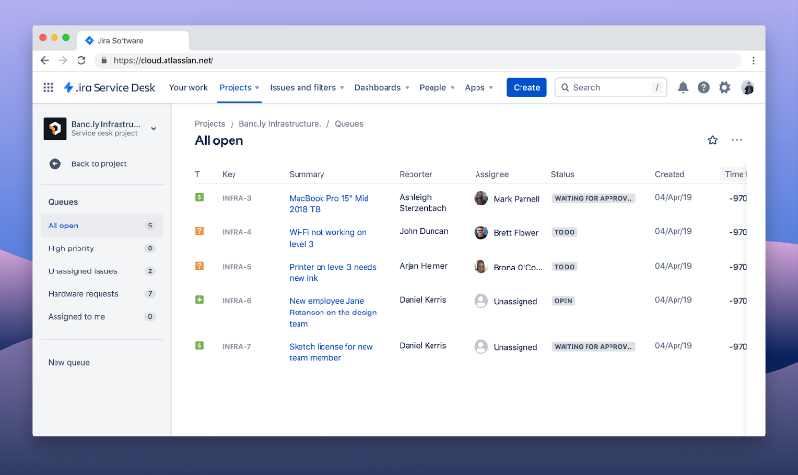

Git hub :

Sudo yum install git --To instal git in aws server --

Git clone – this command used to transfer the directory from remote to local

Cd directory name – to go to that directory

Git add . – used to add the changes

Git commit -m “random name “ – is used to give editor name

Git push- used to transfer the data from local to remote  
?”

.

Gitpush –set-upstream origin (name of the branch)0

Git installation in ec2 remote server:

Command : sudo yum install git

Maven – for java code compilation

To install maven- sudo yum install maven

To compile repository follow this steps:

Cd testapp 🡪 mvn package -DskipTests

After compilation file extension will be .jar, .ear, .war

.jar- core java

.war- web related technologies

.ear- enterprise technology

To compile the file we need pom.xml – for maven

Built.xml—for ant

Pom- project object model

**BRANCH CREATION THROUGH AWS LINUX:**

Git checkout- to swich branch

Git checkout – b –to create branch

To push the branch from aws linux to github—git push - - set-upstream origin name of the branch

Docker hub : ARTIFACTORY REPOSITORY TOOLS

Commets :



Procedure for tools usage

1. Lunch ec2 instances
2. Install git – clone the repository –
3. Install maven—cd (change directory)

Jenkins:

🡪CI/CD TOOL

Un: praveeng6034

P- Gpkc@6034

<http://23.22.63.136:8080/>

add security rules in aws linux path

1. [EC2](https://us-east-1.console.aws.amazon.com/ec2/v2/home?region=us-east-1#Home:)
2. [Security Groups](https://us-east-1.console.aws.amazon.com/ec2/v2/home?region=us-east-1#SecurityGroups:)
3. [sg-019122644251e9379 - launch-wizard-8](https://us-east-1.console.aws.amazon.com/ec2/v2/home?region=us-east-1#SecurityGroup:groupId=sg-019122644251e9379)
4. [Edit inbound rules](https://us-east-1.console.aws.amazon.com/ec2/v2/home?region=us-east-1#ModifyInboundSecurityGroupRules:groupId=sg-019122644251e9379)